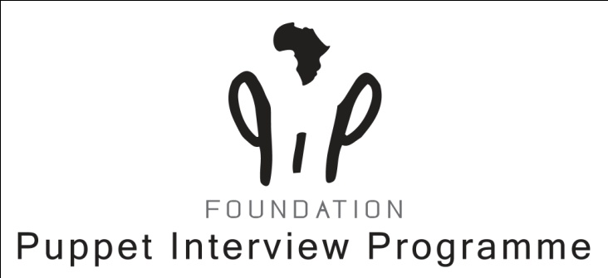
Annual Report 2021
Warmond,December,16th 2021
Dear Board members,
First of all I would like to thank you for your unconditional support and belief in the PIP Foundation!
This year, only one physically board meeting took place due to the Corona restrictions. Communication and consultation were mainly done by phone or mail.
Project: Heel de Mens ICS-SP/PIP/Wilde Ganzen
This year was an exciting year, due to the fact that PIP could partner with ICS-SP the Project ‘HEEL DE MENS ’to train approx. a 100 frontline worker in and around Kisumu. The Project would run from November 2020 until November 2021.
Foeke, the chair, supported and advised in the budgeting for the Project and he negotiated with the director of ICS-SP to come to a reasonable compromise for both parties to support the Project financially.
Wilde Ganzen has been very cooperative with us. PIP had much more difficulties to understand the ICS-SP policies. After signing the contract with Wilde Ganzen /ICS-SP and PIP, we were also asked to make a subcontract with ICS-SP about mutual responsibilities. However, ICS-SP had not been clear to us that PIP was part of one Programme(VACiS program that looks into Violence Against Children in and around Schools) which was meant to end at the end of June meaning that the contracts of many frontline workers would not be renewed. Consequence for our Project, that these frontline workers could not be part of the follow-up supervision meetings and not receive the formal PIP certificate.
ICS-SP left us from the month of June a few months in the dark: They mentioned that they had not budgeted for the 8 Cohorts second supervision meetings that were scheduled from August-till November.
The two Directors(PIP/ICS-SP) had to come to a compromise that not all the Cohorts could benefit from our services which meant that not all frontline workers got their certificate.(only a certificate of participation).
The Project ended in October. PIP sent the Final report (a template format from Wilde Ganzen) to ICS-SP. They filled in their addition part and sent it to Wilde Ganzen.(You find it in an attachment).
I expect their comments within two months from now.
In our PIP team we had to deal with unpredictable behaviour from Mark, which affected George and me when we were approaching deadlines. Another incident between George and Mark almost ended in George (who is the most loyal,honest Keynian person I know) being so upset that he did not want to collaborate with Mark anymore. We were able to sort it out, but the volcano is still burning..
Feedback:
I think that this was a great opportunity for PIP to do a project of this magnitude. We all learnt a lot and upgraded our professionalism. Let’s hope that the work we did to upgrade the expertise of the frontline workers will be helpful in their work with children and families. It would be a great help if ICS-SP would invest to monitor and evaluate how the Methodology was implemented and what the effect is of this different way of counselling.(wishfull thinking…)
Other activities that took place:
Reintegration: The pandemic made some placements delayed because home visits were the first few months not allowed. Remand placed 5 children successfully back(3M;2F) during the year monitored by several follow-ups per child. Close contact stays important!
PIP will continue supporting new selected children to reintegrate them back home to their community.
Refreshers /Presentations:
One refresher took place in January in Kakamega which had been postponed like twice due to disruptive nature of the covid-19, was done under strict adherence to the health guidance protocol, The team had not incorporated the Methodology and had not had the chance to practice (due to COVID).
Outcome: A total recap of the concepts. It was a disappointing experience for our facilitator!!
Presentations:
ICS-SP Inception/PIP introduction meeting with the line stakeholders. Outcome: The stakeholders approved the PIP Programme to train the community frontline workers.
Weza Care Solutions: Is a solutions provider who after the presentation offered PIP a collaboration contract to strengthen one another in different fields. They offer to help us grow in data collecting for reintegration.PIP on the other hand is asked to upgrade the staff in the counselling department with the needed expertise. PIP will provide different trainings programs (basic; advanced; TOT). WezaCare might in the nearby future incorporate PIP and promote us to their big networks of organizations who work with vulnerable children and families.
Kisumu National Polytechnic(KNP): Program manager George was asked to give a presentation to the director of the Counselling Department of the KNP.Aim:1) The teachers lack the skills to guide the students with their troubles issues;2) They also like students to be trained in counselling so that they can offer counselling to their own fellow peers. The need is very high in this school of 18.000 students….Outcome: PIP agreed to make a 3 days tailor-made training for a group of 50 participants.
Afrinov organization (a non –violence approach strategy organization, focusing on injustice violence and conflicts /children problems).Outcome: Afrinov is looking for partnering with PIP in 2022 and like to be trained in the PIP concepts. They will contact a donor who either they will approach or PIP needs to approach to come with a proposal and a budget.

Trainings:
PIP has invested in a big project in Homa Bay.(HB); A reminder of the signed contract: the County Director of the Ministry of Education of HB requested PIP to give a workshop for the subcounty directors and their zonal coordinators. 4 two days workshops; 4 one day workshop.
The agreement and commitment with the signed proposal contained that PIP would take care in budgeting for the workshops and the PIP staff. Ministry of Education would budget for the 400 teachers to be trained in a 5 days programme before the end of this year.
Only PIP kept the promise. After several phone calls and a physical visit from the Program Manager to HB it was clear that there was no budget available.!!
Conclusion: PIP will no longer collaborate with the governmental institutions.
Kisumu National Polytechnic:
PIP was asked to give a 3 days training for 50 participants(a mixed group of lecturers and peer counsellors) to transfer the basic counselling skills with a solution focused approach.
Outcome: The aim was to help both gain the right full skills and knowledge and have the counselling fundaments as a solid base to guidance troubled fellow students. This training actually more lecturing than practicing was unique in its own merit.
Way Forward: If the KNP has find the sources to pay for our services next year, then PIP will provide a tailormade basic level counselling program with small groups of lecturers on our conditions.
Finances:
The financial balance is positive for this year and the coming year. PIP is grateful that the donors are still willing to support us yearly. Besides that it was a great feeling that the Wilde Ganzen wanted to support a part of the Project ‘HEEL DE MENS.’
Tax:
PIP is all and good thanks to George’s contact accountant.
Summary:
PIP can look back on a wonderful intensive, dynamic year and is now already preparing in developing new programs for 2022 for our collaborating with Weza Care Solutions.
I am proud of my team. We overcame the challenges in the collaborating with ICS-SP in a very professional manner.
If WezaCare request our services for trainings ,then we might need to look out for more facilitators to be trained in the PIP Methodology beforehand.

Compiled by Charlotte Kolff

