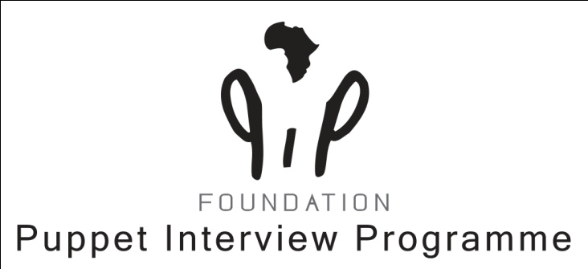

**ANUAL REPORT 2020**

PIP was like any other organization severely hit by COVID-19.After my visit in March, I decided to close the office and let the staff work from home.We all had to get used to a new way of communicating,namely through ZOOM,but we managed well and nowadays we all feel comfortbale with the medium.

**Activities;**

In 2019 PIP supported the following children in their upkeep and schooling

Wendy Buyu University of Nairobi

Tony Ouma Kenyatta University Nairobi

Evans Odhiambo Kenyatta University Nairobi

Luta Buyu Kenya Medical Training College Nairobi

Collins Otieno Onyango Onjiko Highschool Ahero

Luke Buyu M.M. Shah Primary school Kisumu

Susan Asio Omondi

Regular contact and support was provided to the children some of them living on campus in Nairobi others around Kisumu. The strikes of teachers caused problems in the regular school year and delays in completing of the courses.

* **Training teachers:**

The schools closed so the Ministry of Education from Kisumu County informed us to wait with our proposal to train their ECDE teachers when the schools would reopen…From our side we tried to keep in touch with them mentioning to be proactive and train the teachers even with an extra day with ‘Safe guidelines for children to go back to school’, but it didn’t work. The Ministe,r who was our contactperson and who wanted to promote it sincerly, was replaced and that was the end of it.

Lucky enough, PIP was requested to train a Primary school in a different county (HomaBay)through a former connection who was impressed by the Methodology. Being a boardmember of that school he asked PIP to train their teachers.

**Outcome:** This boardmember(pastor) convinced the County Director of the Ministry of Education of HB and within no time PIP was requested to give a workshop for the subcountydirectors and their zonalcoordinators. 4 two days workshops; 4 one day workshop.

The agreement and commitment with the signed proposal contained that PIP would take care in budgetting for the workshops and the PIP staff. Ministry of Education would budget for the 400 teachers to be trained in a 5 days programme before the end of this year.

The workshops were a tremendous success and with the COVID in mind so well prepared.( i sent you earlier on the reports).

Untill now the County Director(HB) has communicated that the money has not been released from the Central Government.Way forward means waiting till there will come a green light..

* **Reintegration**

Due to COVID all activities in the institution stopped.It was me,so concerned about the children placed back home to consider a way of keeping in contact with them. With the help of PIP money and a booklet which informs the child about COVID,I empowered our programmanager to encourage the Remand team to help the children in the institute and guide the families through phonecalls in their communities. This was succesfull in the sense of connection. However it became harsh for two families who were affected by the economic circumstances and their lack of containment; the two boys who were well reintegrated fell back into their old bad behaviors, influences by peergroups.

From October it was possible to travel again and hopefully the ‘damage’will not be that severe to restore the broken connections.We still continue with new children supervised by George.

* **Partnering with ICS-SP**

George made it possible to connect PIP to the programmanager of ICS-SP Kisumu. A local Kenian organization.They recognized immediately how our Methodology could be beneficiary for their staff.

**Outcome:** After the letter of intent, PIP could start the process with Wilde Ganzen and ICS-SP formally.

* **PR PIPMETHODOLOGY**

PIP strongly believes that the Metholodogy should not be kept for itself,but what could be a good way to sell this ‘wonderful’product?

After several discussions even with a new consultant, we had a better idea what promoting PIP should entail in making another video.It would not only contain the practitioners who have been trained and implemented it in their work, but we also needed an interview with a manager who is a decisionmaker and motivates why this methodology is importnat for his institute.The PIPteam did the shooting.

**Outcome:** the Benefits of the PIP Methodology is inserted on the website(video gallery)I also have the clips made seperately to post them on Facebook.

2021 will be the way to be more on social media alos with your help ofcourse.

The PIP Methodology is even now virtual online.You can also find us in the Directory of Organizations of Better Care Network International and in the toolkit of Better Care Network Netherla

**Summary:**

PIP not only survived, but we managed to get a wonderful new project that will bring so much light and a bright future with a lot of work!! We are strong believers and are able to keep the passion and the spirit high.

Charlotte